Title: Phishing Email Analyzer
Introduction: Phishing is a widely used cybercrime technique where attackers send deceptive emails designed to appear legitimate. These emails often impersonate trusted organizations such as banks or service providers in order to manipulate recipients into clicking malicious links or sharing confidential information.
This project focuses on the technical examination of a suspicious email using header analysis, authentication verification, IP reputation checks, and URL investigation to determine whether the email is malicious.
2. Understanding Phishing Attacks
Phishing refers to a social engineering attack in which fraudulent emails are crafted to mislead users into revealing sensitive information such as login credentials, banking details, or one-time passwords. These emails commonly create urgency or fear to increase the success rate of the attack.
Primary Goals of Phishing
- Stealing user credentials
- Financial exploitation
- Malware distribution
- Identity misuse
3. Common Phishing Techniques
- Email Phishing: Bulk phishing emails sent to random users
- Spear Phishing: Targeted attacks aimed at specific individuals
- Whaling: Phishing attempts focused on senior executives
- Smishing: Phishing via SMS messages
- Vishing: Phishing through voice calls
- Clone Phishing: Modified copies of legitimate emails with malicious content
3. Email Authentication Protocols:
SPF (Sender Policy Framework)
SPF checks whether the sending mail server is authorized to send emails on behalf of the claimed domain.
DKIM (DomainKeys Identified Mail)
DKIM uses digital signatures to verify that the email content has not been altered during transmission.
DMARC (Domain-based Message Authentication, Reporting & Conformance)
DMARC works alongside SPF and DKIM to define how receiving mail servers should handle authentication failures.
5. Tools and Technologies Used
- Email Header / EML Analyzer
- VirusTotal (IP and URL reputation analysis)
- AbuseIPDB (historical abuse data)
- urlscan.io (URL behavior analysis)
- Browserling (safe website testing)
- MXToolbox (email authentication verification)
- nslookup (DNS validation)

6. Step-by-Step Investigation Process
Step 1: Email Header Examination
Observations:
- The sender email impersonates a banking institution (Bradesco Bank)
- The originating IP address was identified
- Email authentication failures were detected

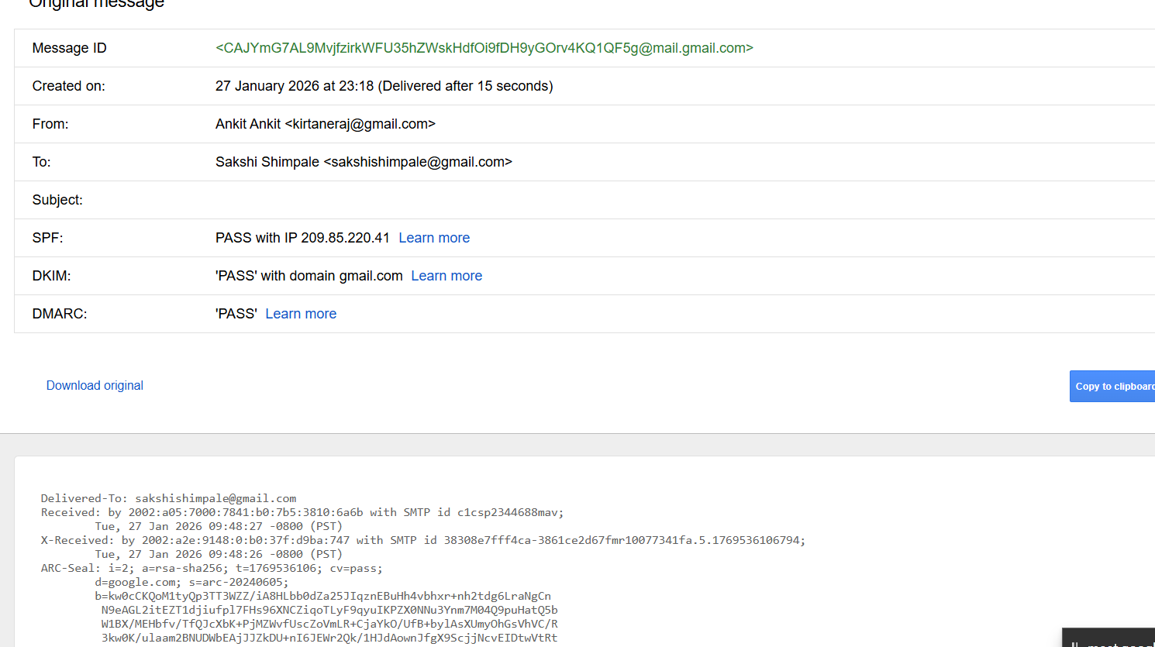
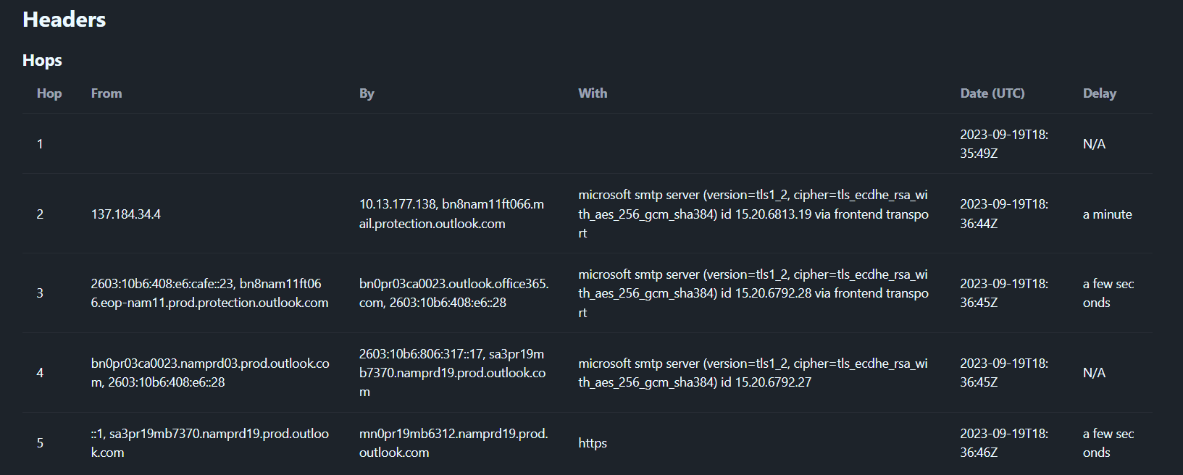 Step 2: Authentication Result Analysis
From the authentication-results header:
- SPF: Temporary failure
- DKIM: Not present (email unsigned)
- DMARC: Not compliant
These results indicate spoofing attempts and improper email configuration.
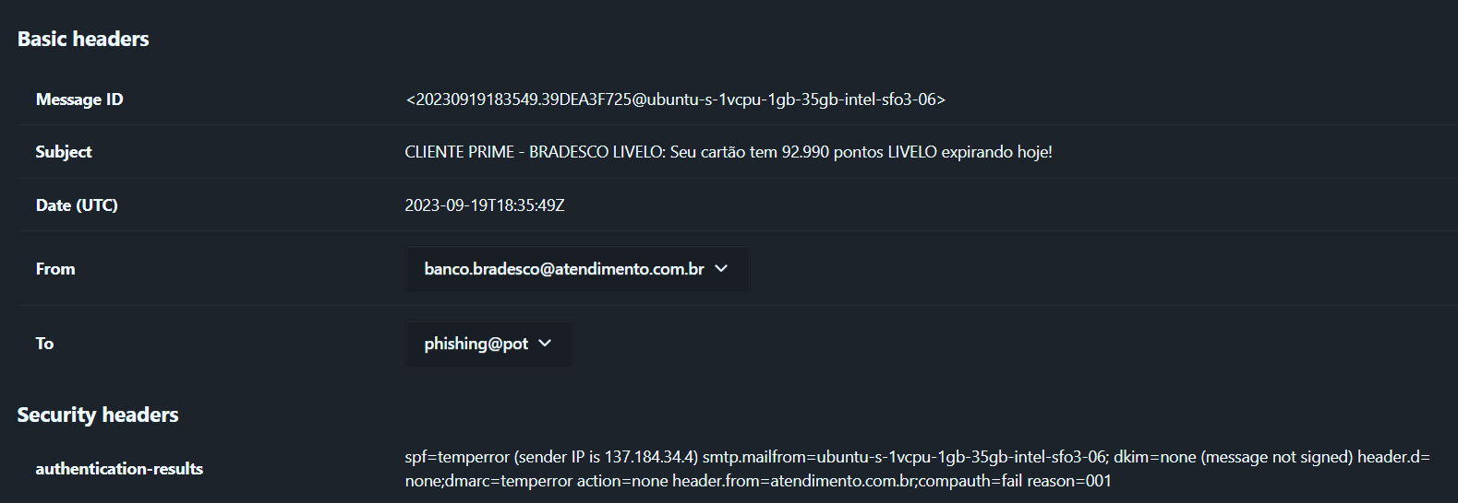
Safe Website Testing
- The website failed to load during browser testing
- This behavior is typical of phishing pages that are taken down after campaigns
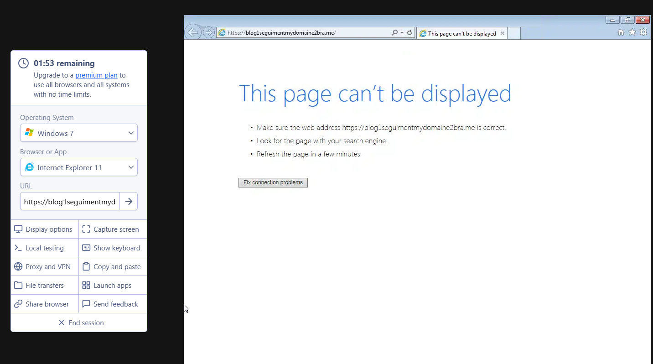
Step 3: Sender IP Reputation Analysis
- IP Address: 137.184.34.4
- VirusTotal: No active detections
- AbuseIPDB: Historical abuse reports detected
- Hosting Provider: DigitalOcean (frequently misused for phishing campaigns)
Inference:
Although not currently blacklisted, the IP shows suspicious characteristics.

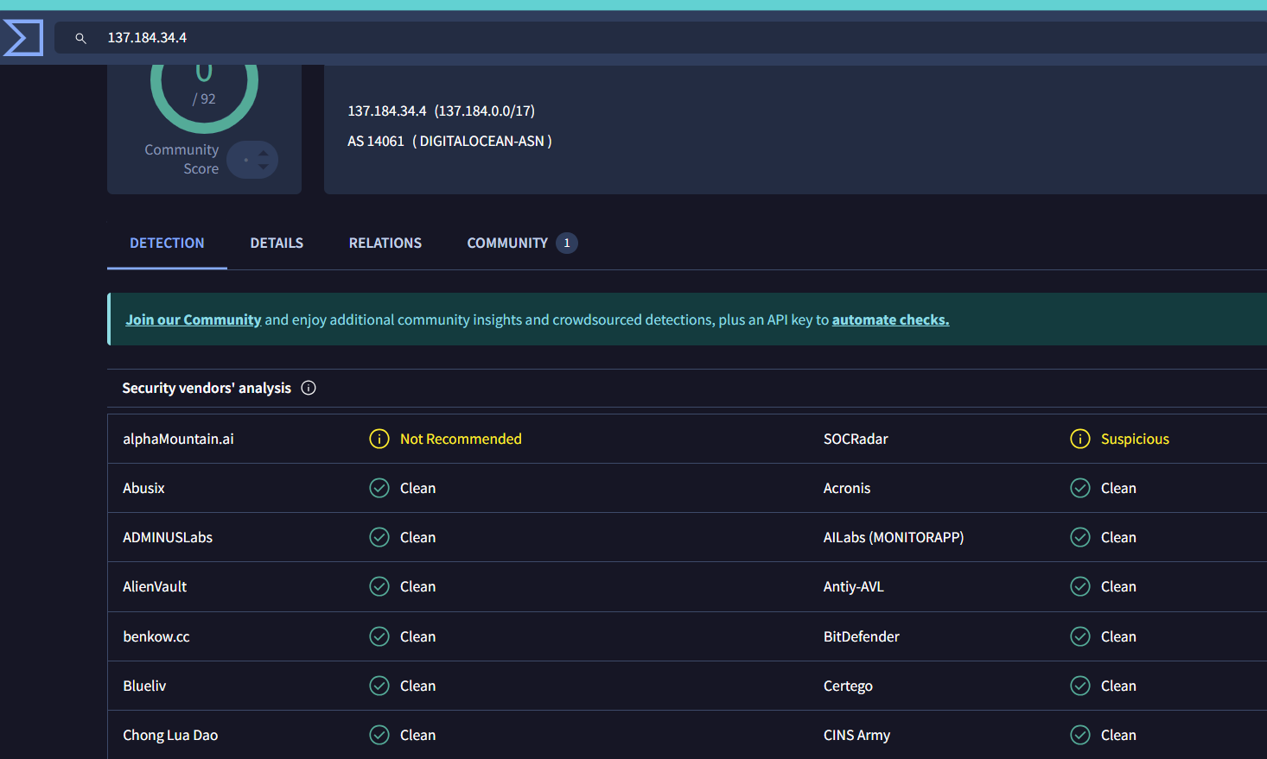
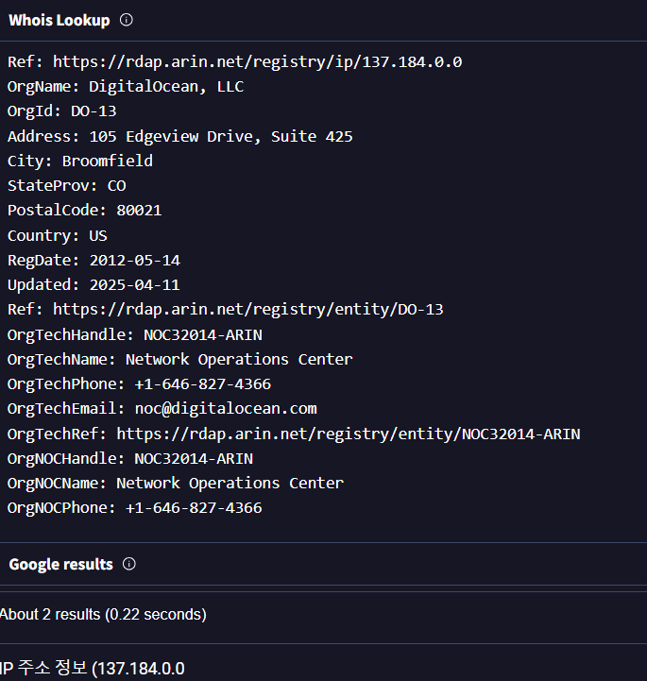

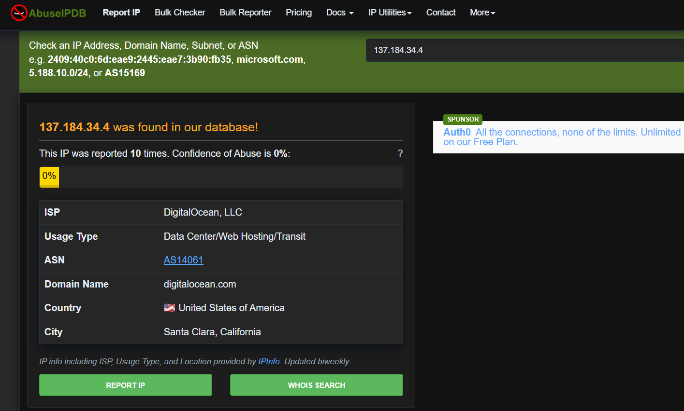
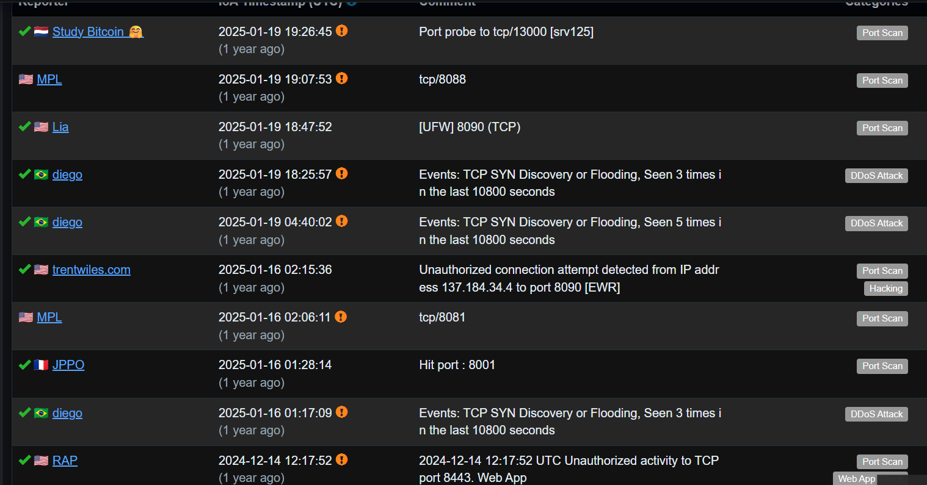
URL and Domain Analysis
Identified URL:
https://blog1seguimentmydomaine2bra.me/
Findings:
- Domain name does not match the claimed organization
- Randomized naming pattern observed
- urlscan.io shows multiple past scans and phishing-style landing pages

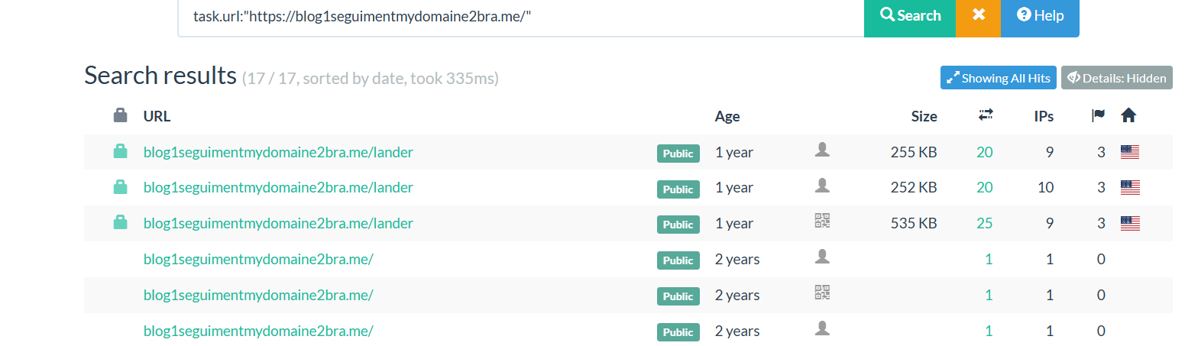
6: MXToolbox Verification
- SPF Authentication: Failed
- SPF Alignment: Failed
- DKIM Authentication: Failed
DMARC Record: Missing
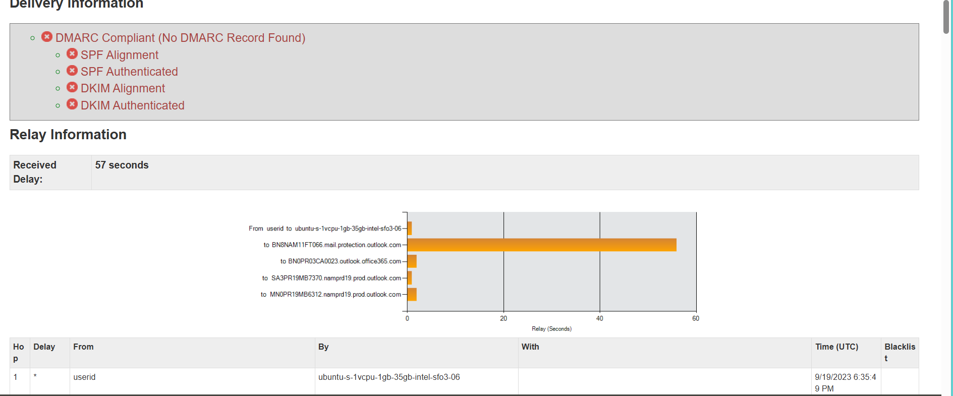
7. Investigation Questions & Answers
Q1. Sender email address?
banco.bradesco@atendimento.com.br
Q2. Sending domain?
atendimento.com.br
Q3. Sender IP address?
137.184.34.4
Q4. Is the IP blacklisted?
No (only historical abuse records)
Q5. SPF authentication result?
Fail (temperror)
Q6. Suspicious URL found?
https://blog1seguimentmydomaine2bra.me/
Final Outcome
- Confirmed phishing activity
- Detected authentication failures (SPF, DKIM, DMARC)
- Identified suspicious sender infrastructure
- Analyzed malicious URL behavior using multiple tools

Conclusion:
- The analyzed email exhibits multiple phishing indicators, including brand impersonation, email authentication failures, cloud-hosted suspicious infrastructure, and a malicious external link. Despite successful delivery, the technical evidence confirms that the email is fraudulent. This analysis highlights the importance of comprehensive email inspection beyond surface-level delivery success.
Learning Outcomes:
- Gained practical experience in phishing email detection
- Developed understanding of SPF, DKIM, and DMARC
- Used real-world SOC tools for investigation
- Improved incident analysis and reporting skills

